**Metaphor/Architecture Specification Template**

|  |  |  |  |
| --- | --- | --- | --- |
| Student | Umbrella | Date | 15/Abr/2015 |
| Cycle | 1 | Program # | CSOF |
| Instructor | Luis Daniel Benavides Navarro | Language | JAVA |

|  |  |
| --- | --- |
| **Design** | 1. Controlador |
| **References** | 2. Modelo |
|  | 3. Vista |
|  |  |
|  |  |

**Graphical representation of the metaphor**

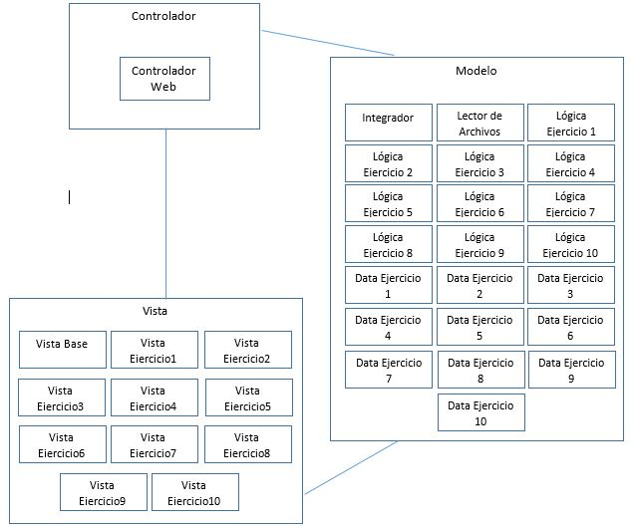

**Textual representation of metaphor**

|  |
| --- |
| Se esta manejando el patron MVC para implementar en un solo proyecto todos los requerimientos |
| existentes, 2. Extrae los datos de los ejercicios planteados y por medio del integrador envia los datos |
| solicitados al Cntrolador, 1. Organiza los datos de forma legible para la Vista, 3. Muestra los datos en una interfaz web al usuario |

Metaphor/Architecture Specification Template Instructions

|  |  |
| --- | --- |
| Purpose | * To contain the metaphor for a program, component, or system * To enable precise, rapid and complete design understanding * To facilitate thorough design and implementation reviews and inspections |
| General | * Use this template to document the program’s high-level metaphor. * The metaphor could be based in common programming patterns as MVC, or architectural styles as tree layer design, client-server, or inversion of control frameworks * After implementation and testing, update the template to reflect the actual implemented product. * Use plain language and avoid using programming instructions wherever practical. |
| Header | * Enter your name and the date. * Enter the program name and number. * Enter the instructor’s name and the programming language you are using. |
| Design References | List the references used to produce the program’s logical design.   * the Operational, Functional, and State templates * the program’s requirements * any other pertinent source |
| Graphical representation of the metaphor/Architecture | * Create a graphical representation of the main program parts and its interactions * Use clear names for each part * Use edges with arrows to show interactions * Use descriptive names for the interactions |
| Textual representation of metaphor | * Use text to describe the main idea and metaphor used in your design * Describe the graphical representation using common language |